**Fusion Wear Looks To Carry Off This Festive Season**

Ah, festivals. The perfect occasions to dress up, whet the appetite, and have fun. But what about those heavy, fancy clothes, suit design that get in the way of your merrymaking? We say, change it up! After all, tradition doesn’t have to be cumbersome.

Festive clothing has come a long way from our grandmothers’ Banarasi sarees. Modern festive clothes need to match the rhythm and pace of the women of today. Do they reflect tradition and grandeur? Yes. Can they be comfortable enough to shake a leg in? Definitely yes!

Glittering sequins are replaced by intricate embroidery. Glitzy gold and silver work by fashionable prints. And yards and yards of fabric with practical, contemporary silhouettes. Yet, there is something inherently Indian about Biba’s fusion festive collection. So you can stay yourself while still earning those approving looks from mommy dearest.

Check out these stylish fusion wear looks by BIBA!

**Nothing Beats A Lehenga**

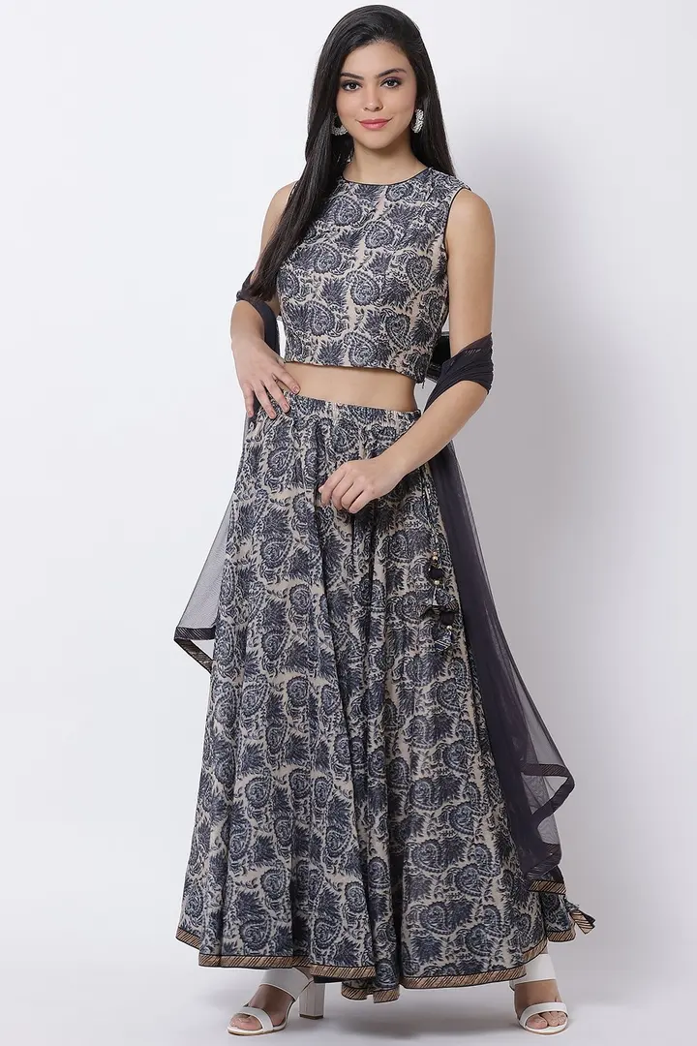

*A fashionable printed lehenga and crop top set that you can mix and match*

[Shop the Look](https://www.biba.in/blue-poly-cotton-lehenga-set/p/15335297/11832229)

From Bollywood movies to pop music videos, everyone’s going ga-ga over a lehenga set. And it’s not a surprise that the lehenga is one of the most flattering and sensual Indian clothing. Plus, you can easily incorporate it into your festive wardrobe.

No, sir. The gorgeous lehenga is not limited to the bridal trousseau anymore. With soft, comfortable fabrics, playful patterns, and a range of funky colours, the lehenga has made its way into the hearts (and closet) of the free-spirited modern girl.

Want a style tip? The contemporary lehenga is more or less a crop top and long skirt. So if you’re thinking “Where will I wear this lehenga again?” We’ve got a simple solution. Try the choli (or top) on your jeans or palazzos when heading out with friends.

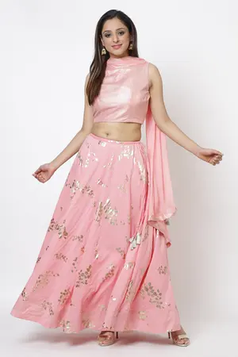

*Add oomph to your festive look with this glamorous yet comfy baby pink lehenga*

[Shop the Look](https://www.biba.in/blush-pink-cotton-lehenga-set/p/15335021/11830761)

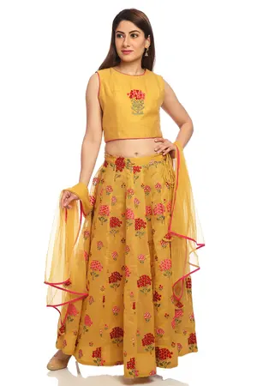

*Keep it colourful with this mustard yellow floral print lehenga*

[*Shop the Look*](https://www.biba.in/mustard-floral-lehenga-set/p/14519243)

**Classy 3-Piece Suit**

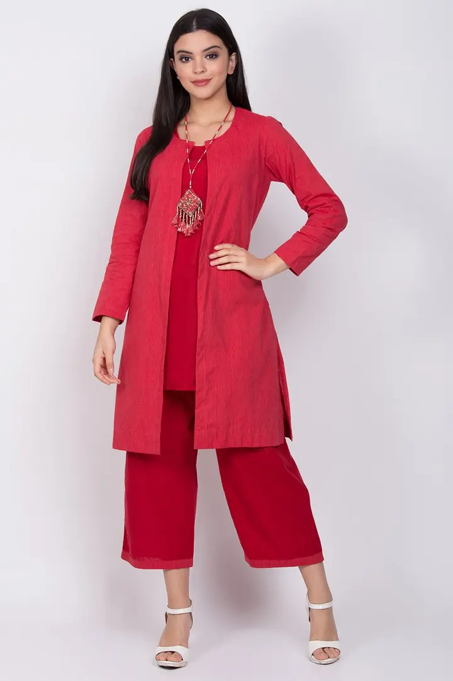

*Get the monochrome look with this understated 3-piece set*

[Shop the Look](https://www.biba.in/lime-green-cotton-straight-3-piece-set/p/15334215)

Ah, the age-old dilemma - “I want to buy this, but where will I wear it?”

Not to worry. We’ve got a fix for that. How about a mix-and-match 3-piece ensemble? Which can easily replace your boring **cotton suit set**. Put together, they create a snazzy indowestern festival look. But you can also wear them apart every day without a second thought. Goals right?

How about a set of fusion wear? A quirky dhoti pants with a crop top and printed jacket? Or maybe a combo of short kurti with a shrug and culottes? All you need to do is add the right jewellery and accessories to look dazzling this festive season.

Festivities over? Swap out the traditional pants for jeans. Or simply use the jacket on one of your casual outfits. Even by itself, the sophisticated 3-piece suit looks classy enough for multiple occasions. You can also replace your daily wear straight suit set with these contemporary styles.

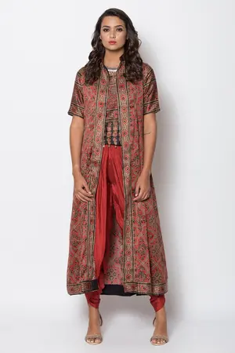

*Look traditional yet modern with this dhoti pants, printed top and long shrug set*

[Shop the Look](https://www.biba.in/rust-poly-modal-three-piece-set/p/14987263)

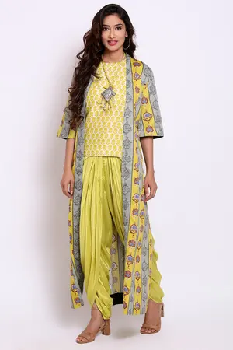

*Stay quirky and colourful with this 3-piece dhoti pant, jacket, and short top set*

[Shop the Look](https://www.biba.in/lime-green-cotton-straight-3-piece-set/p/15334215)

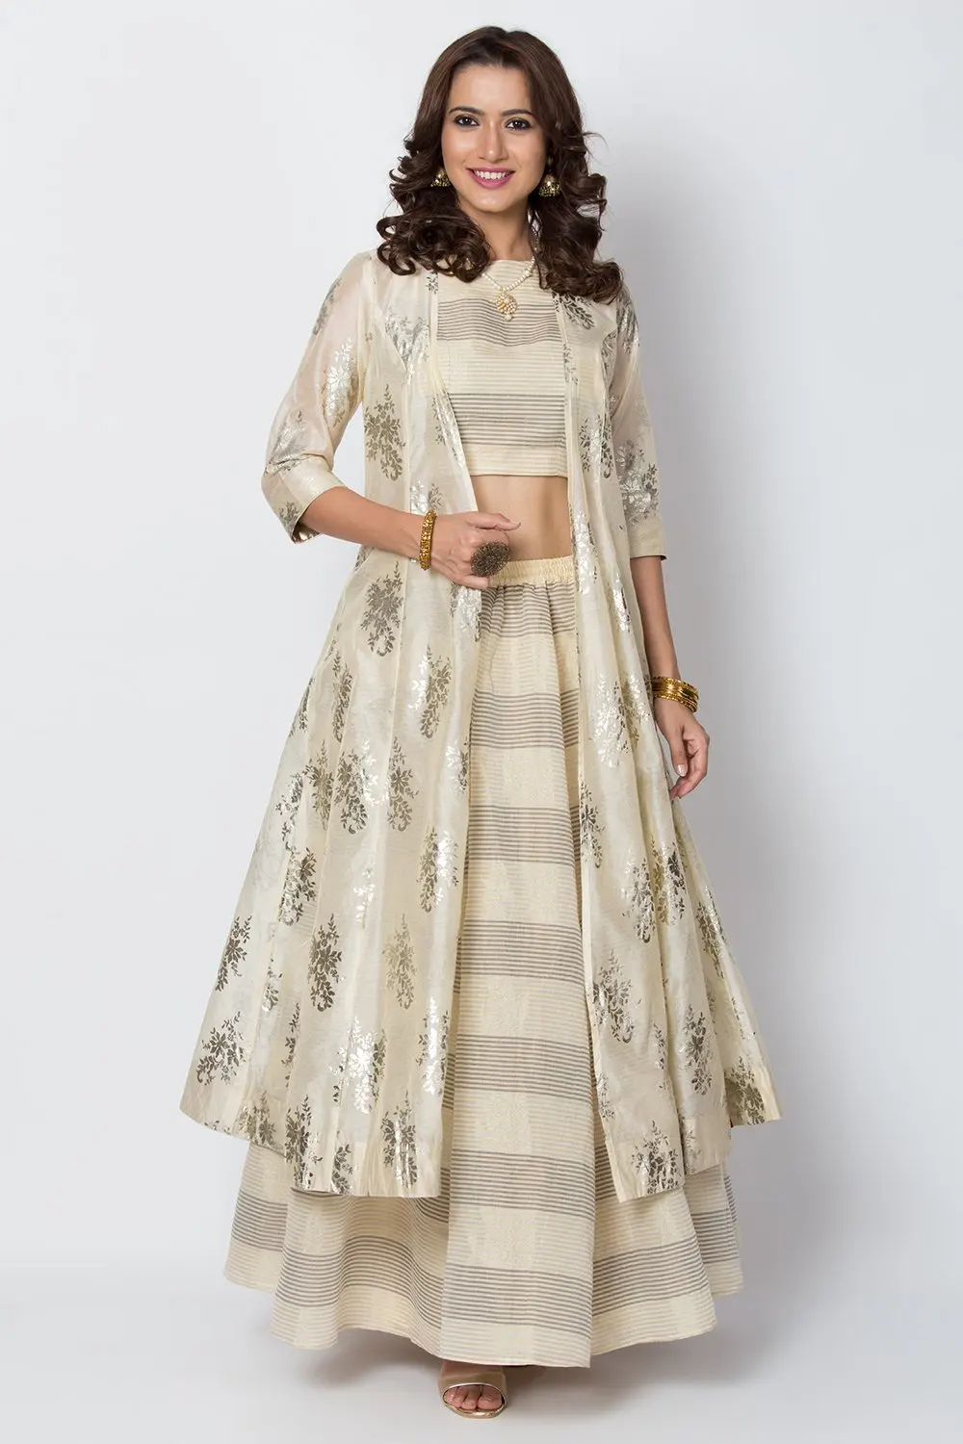

*Switch it up with this gold foil Lehenga, shrug and top set*

[Shop This Look](https://www.biba.in/light-beige-poly-cotton-short-top/p/14858103)

**Festival-Approved Dresses**

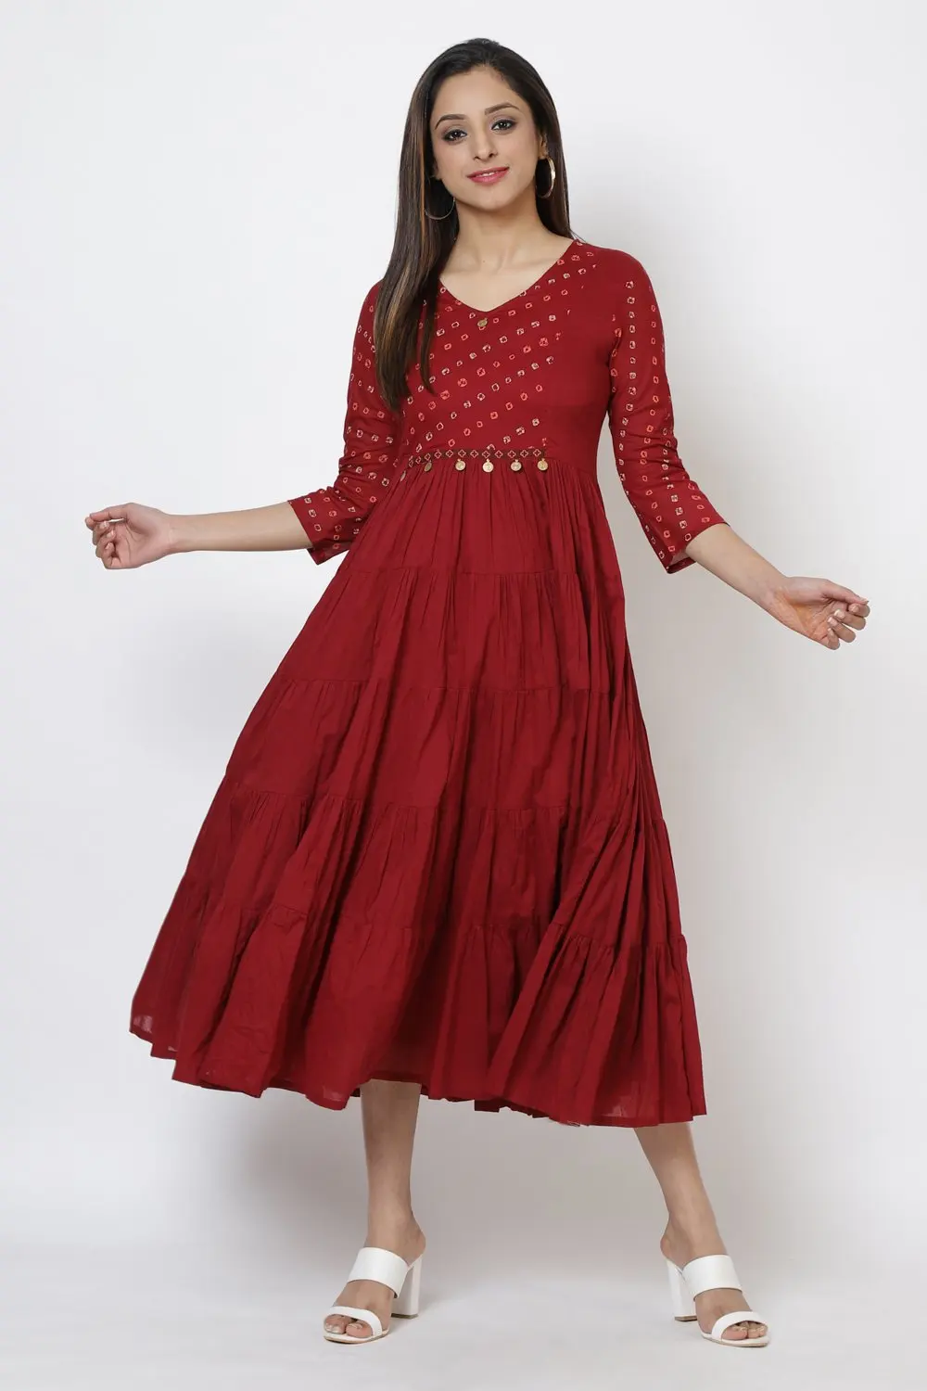

*This maroon tiered dress with coin detailing is the perfect fusion wear this festival season*

[Shop This Look](https://www.biba.in/maroon-cotton-dress/p/15926027/12591227?nw=PLP-PPR)

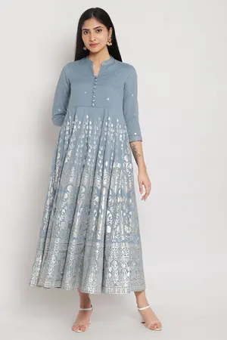

*A stylish festive dress with intricate metallic foil print*

[Shop the Look](https://www.biba.in/blue-cotton-dress/p/15926025/12591181)

A dress? At a festival? Calm down. Calm down. These dresses won’t leave the aunties clutching their pearls. They walk the tightrope between being fashionably modern and beautifully ethnic.

The festive fusion dresses come in every silhouette - there’s tiered dresses, kaftan-style dresses and straight maxi dresses. Phew! That’s a lot of choices there. And not to mention all the fun prints and colours.

So dare to be different this festive season, and try these comfy dresses. They look perfect during a traditional ceremony when you pair them with leggings. Or at that get-together with the family when you spruce it up with the right accessories.

Festivals are fun. Especially if you get to dress up the way you want. So don’t let convention get

in the way of expressing yourself. Classy? Quirky? Fancy? Whatever may be your personal

aesthetic, you can find something special for the festival season at BIBA. Talk about versatility,

right?

|  |  |
| --- | --- |
| https://www.biba.in/new-arrivals/suit-sets | suit design |
| https://www.biba.in/new-arrivals/suit-sets/straight | straight suit |
| https://www.biba.in/suit-set/fusion-wear | fusion wear |
| https://www.biba.in/suit-sets/lehenga-set | lehenga set |
| https://www.biba.in/cotton-suit-sets-collection | cotton suit sets |